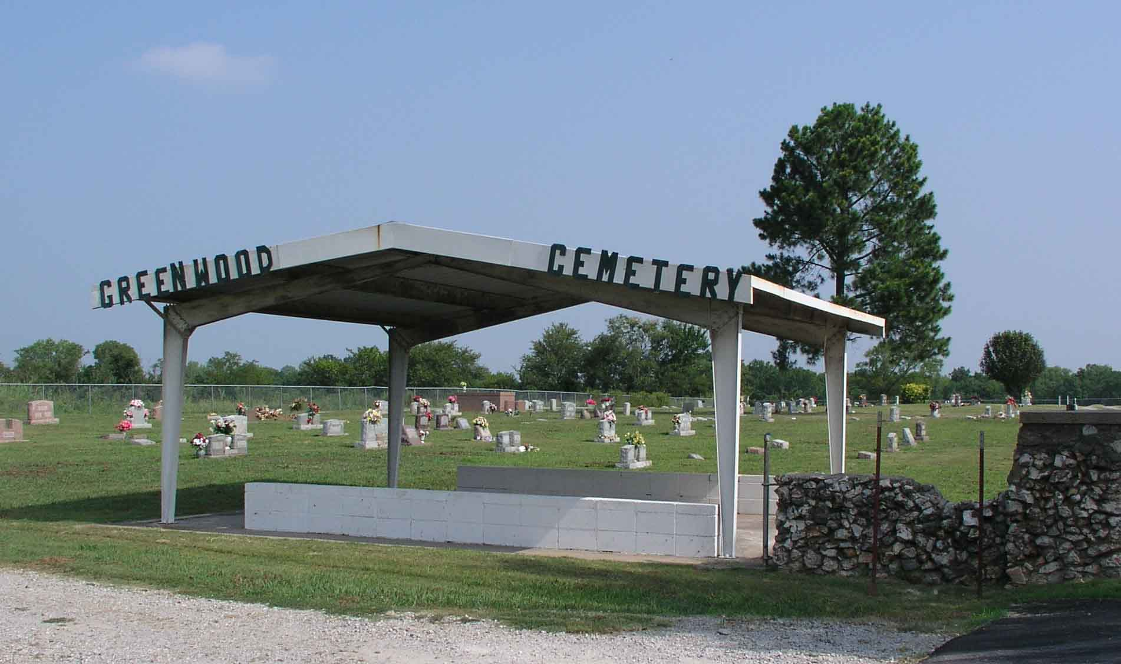

1. Charges for interment, opening and closing graves, single grave spaces and lots and care and maintenance of cemetery lots shall all be set by resolution by the board of trustees.
2. The lack of a current address of the owner of such unused lots for a period of twenty (20) years shall cause lots to be deemed abandoned by owner and ownership shall revert back to the town and may be resold.
3. Graves shall be opened and closed by the town only; graves shall not be opened or closed on Sundays and Holidays.
4. All gravesite services or services during inclement weather at Greenwood Cemetery shall be held at the shelter with interment occurring after the services.
5. Alleyway’s in the cemetery shall remain closed at all times.
6. The cemetery gate shall be closed from dusk to dawn.
7. It shall be unlawful to loiter within the cemetery.
8. It shall be unlawful to ride horses within the cemetery.
9. It shall be unlawful for an unauthorized person to disturb, remove or take flowers or other grave decorations from any lot or grave space in the cemetery.
10. It shall be unlawful to vandalize property within the cemetery.
11. No diesel or oil base weed killer may be used in the cemetery at any time.
12. Any person, firm or corporation violating this section or any part thereof shall be deemed guilty of a misdemeanor: and upon conviction thereof, shall be punished as provided in Section 1-108 of this code;
13. All prices, fees or charges that are to be set by resolution shall be subject to change by subsequent resolution when deemed necessary by the town of board of trustees.

(added 1990, amended 1993)

1. The Town of Porter Oklahoma is not responsible for damage of any headstone resulting from a natural disaster.

Rules and Regulation

Of

Greenwood Cemetery

Porter Oklahoma

Greenwood Cemetery

**FORWARD**

Greenwood Cemetery is at the North end of Main Street in Porter Oklahoma. Greenwood Cemetery does not want to interfere with individual taste in the construction or erection of monumental work but to protect the interest of each separate lot owner they, the cemetery committee, reserves unto themselves explicitly, the right to prevent construction or improvements which might interfere with the general effect or welfare of the cemetery.

Greenwood Cemetery is owned by the Town of Porter and 25% of each lot sale to be put into the cemetery land fund.

While some of the rules may appear arbitrary, each however, has been adopted for the specific purpose of protecting the lot owners and too insures the beauty, character and distinction of Greenwood Cemetery. They apply to every lot owner and ever visitor of the cemetery and it is hoped that they will be duly appreciated and properly respected.

CEMETERY COMMITTEE

SHARON PAYNE 918-638-1912

Mary Shephard – Gist 918-351-5782

MICKI WILLARD 918-760-0883



Donations can be mailed to the

Town of Porter

P.O. Box 149

Porter OK 74454

Rules and Regulations Section 11-104

1. It shall be unlawful for any person to place curbs, enclosures, walks or any other permanent obstruction in the cemetery.
2. Trees, shrubs, or flowers shall not be planted in the cemetery except under the supervision of the caretaker.
3. Cemetery officials reserve the right to have removed any structure or object they may deem objectionable.
4. Flowers shall be displayed only on headstones during mowing season except for Memorial Day and new gravesites. Flowers displayed for Memorial Day shall be removed the first Monday following Memorial Day. Flowers shall be removed from new gravesites after seven (7) days.
5. It shall be unlawful to fill lots above the established grade of the cemetery or fill graves above the level of the lots.
6. No person other than the owner or member of his immediate family shall be buried in any plot without the written consent of the owner thereof.
7. No interments shall be made unless the plot has been paid for to the town.
8. Human bodies only shall be buried in the cemetery.
9. Multiple interments in single space. No more than one interment shall be permitted in a single space, except that in the case of a mother child, two infants buried in one casket, a normal interment and one cremation may be in a single space, or two cremations may be placed in a single space.
10. All headstones must have a concrete base. All monuments and markers must be set on the plot line and shall be set by the monument company or by the caretaker. Veteran’s markers can be used for a headstone or put at the foot of grave within the boundaries of the plot. Charges for setting headstones shall be stablished by resolution of the board of trustees.
11. No markers shall be allowed which are made of any perishable materials such as wood or sandstone.
12. A concrete or steel box is required as an outside enclosure in all burials in the cemetery.
13. Cemetery lots are non-transferable. Any resale of such lots shall be to the town at a price equal to sixty percent (60%) original purchase price.